**Analytics Screenshots:**

**Table Creation and Merging through Hive For Yelp:**

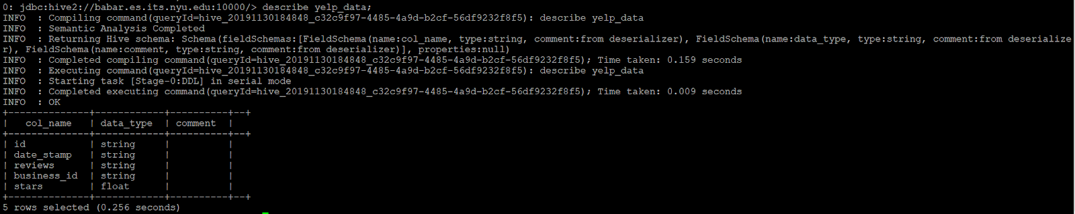

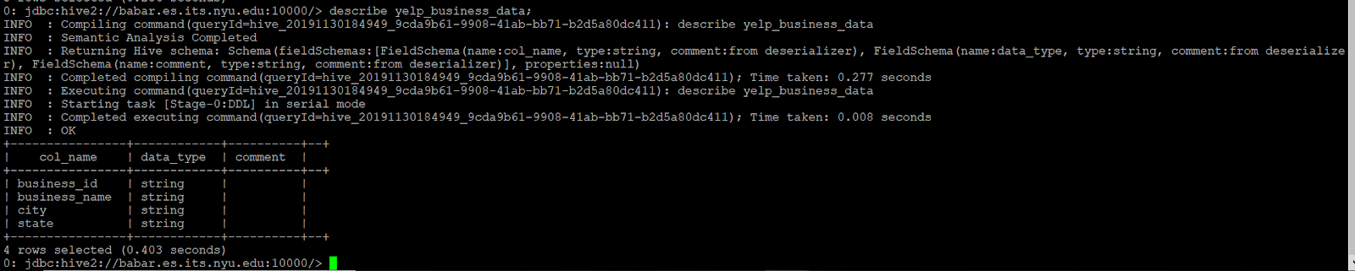

**Taking Data in Text File from Hive:**

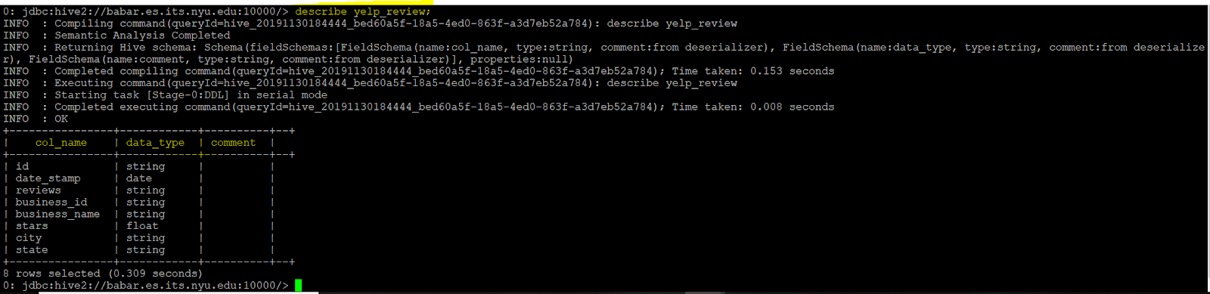

**Table Creation in Impala for Twitter Data :**

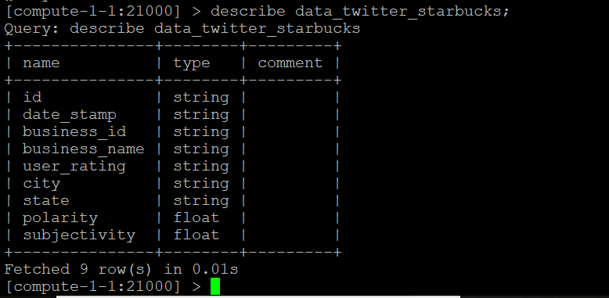

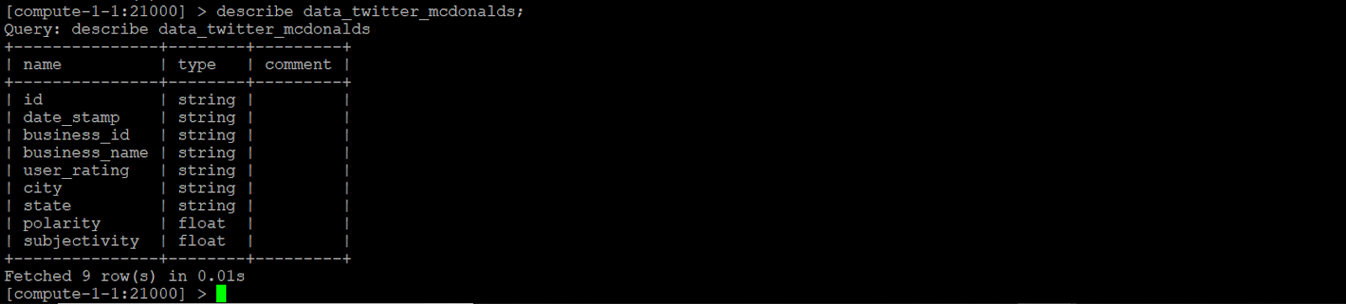

**Table Creation in Impala for Reddit Data :**

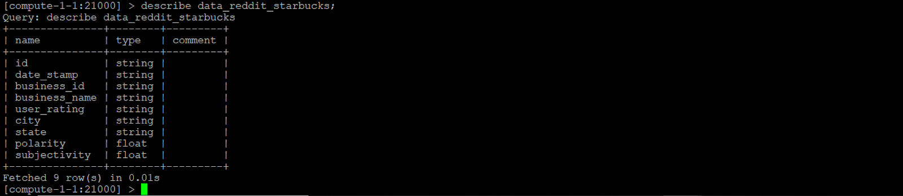

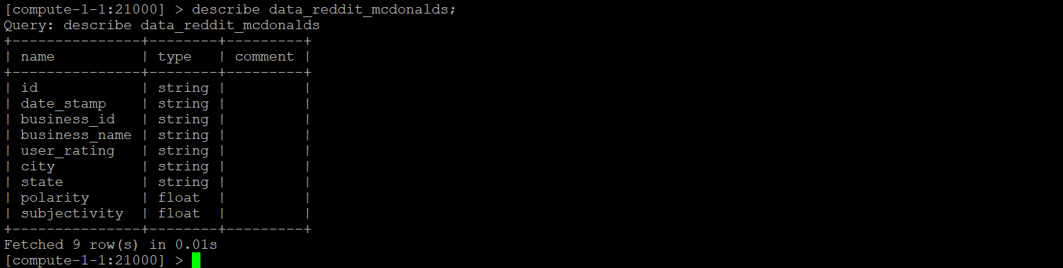

**Analytics Run for YELP :**

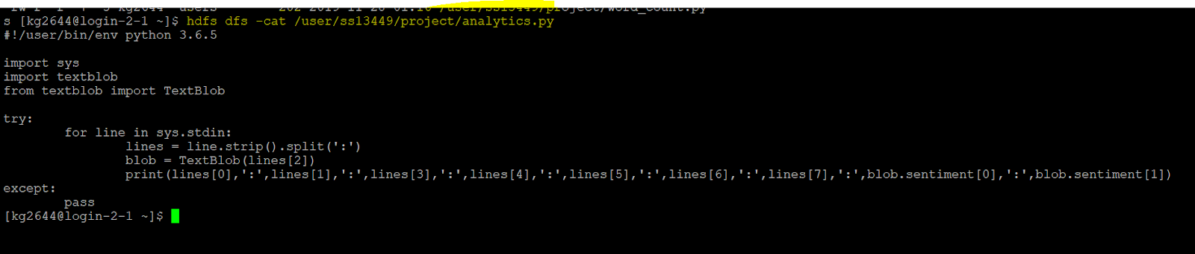

Below is the screenshot , after successfully executing the above command :-->

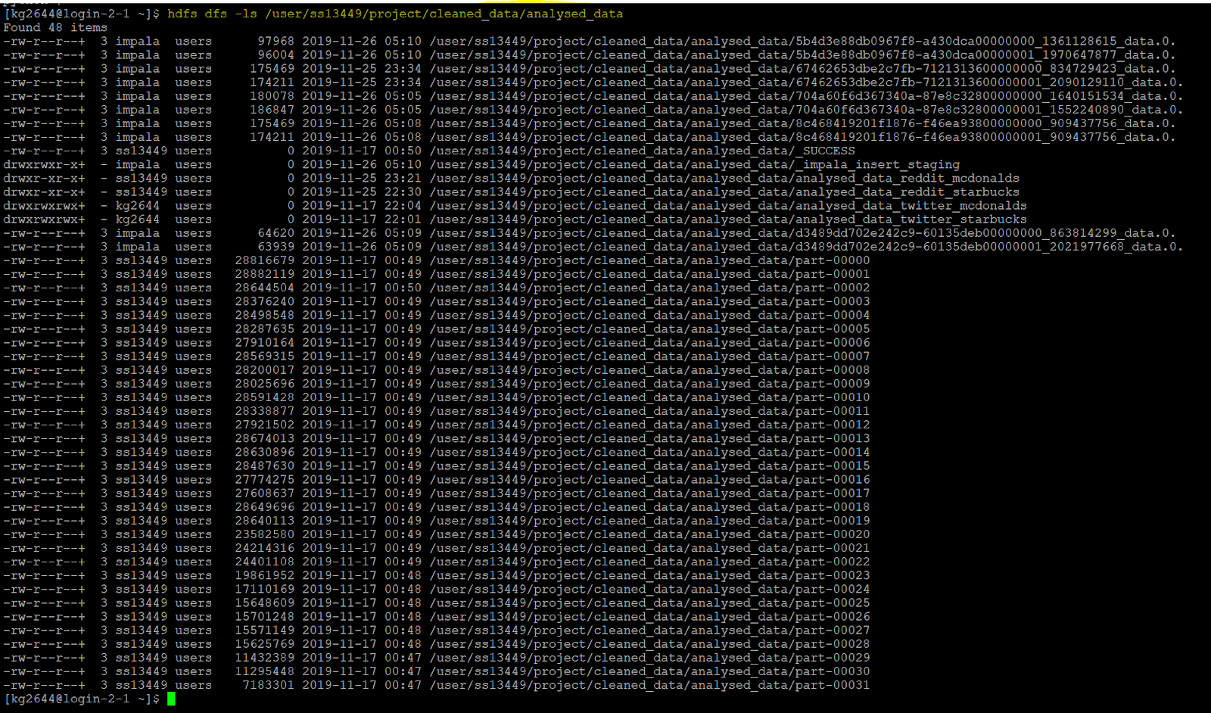

**Analytics Run for Twitter:**

***Starbucks***:

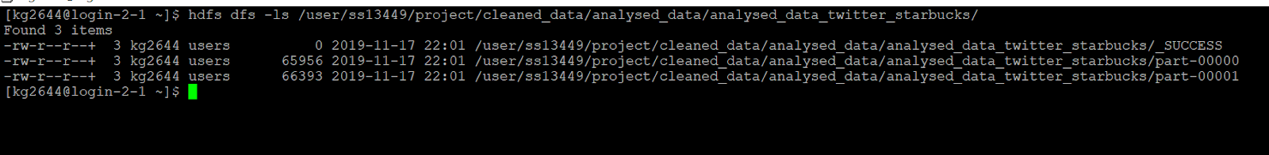

***McDonald’s:***

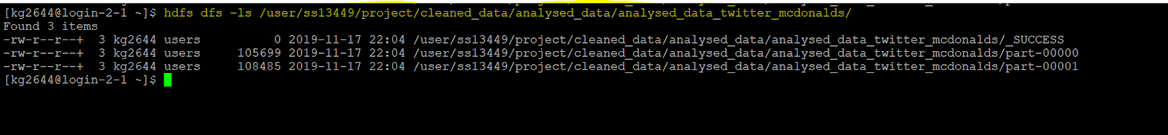

**Analytics Run for Reddit:**

***Starbucks***:

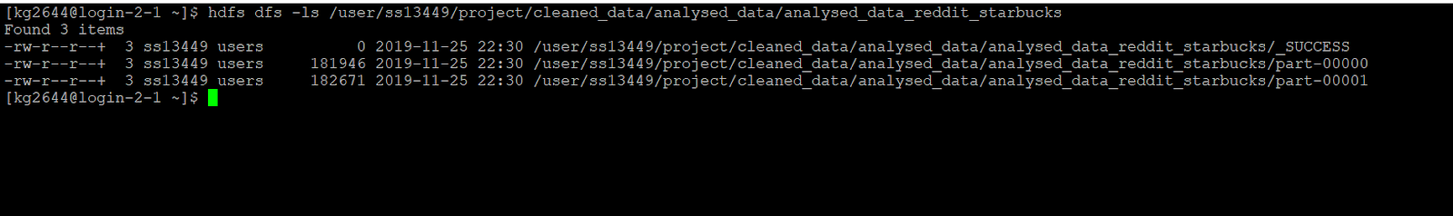

***McDonalds***:

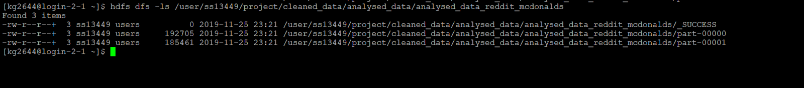

***PROBLEM-1 & PROBLEM-2*:**

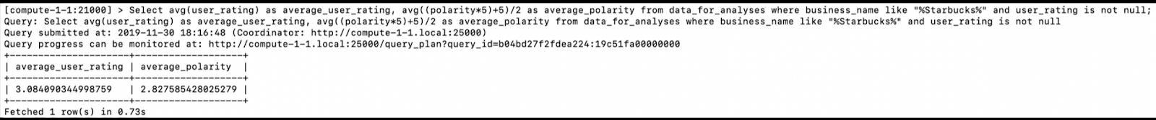

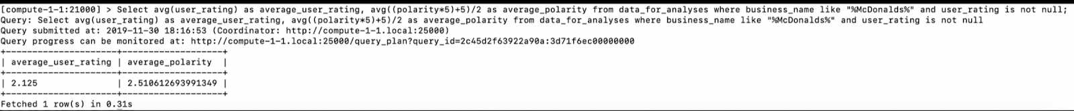

***PROBLEM -3***:

**STARBUCKS:**

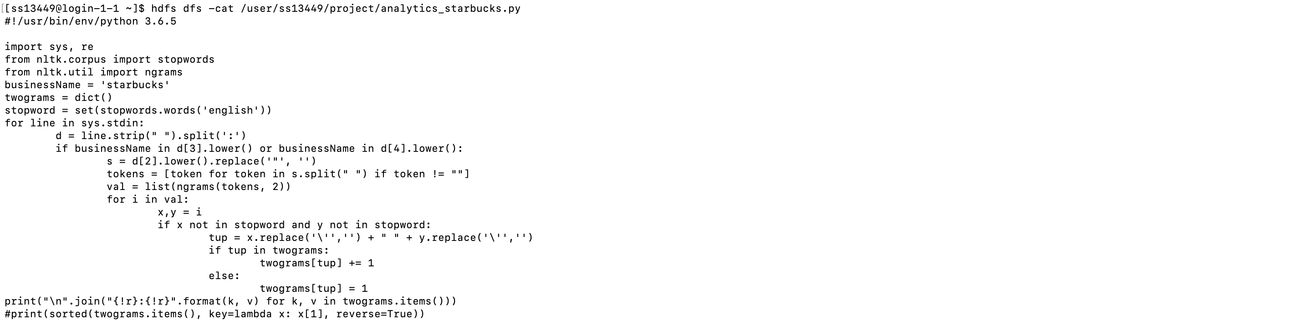

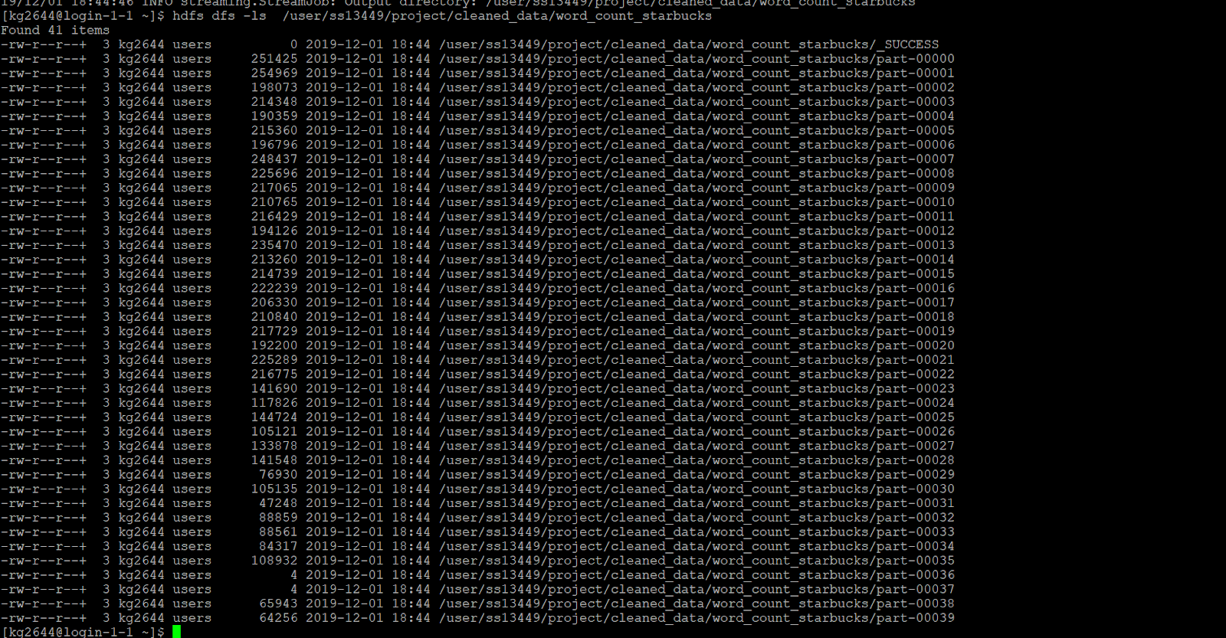

**McDONALDS** :-

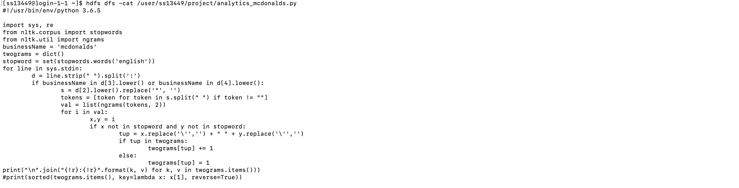

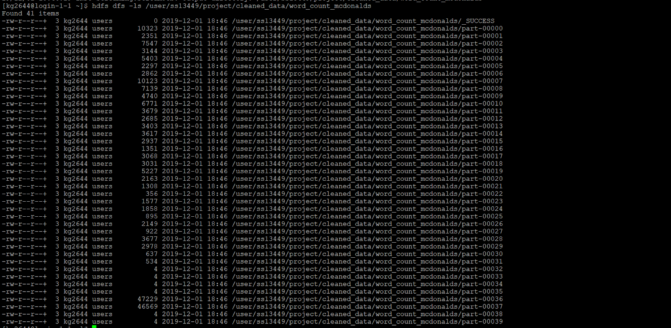

**Analyses of Top topics in impala:**

Starbucks:

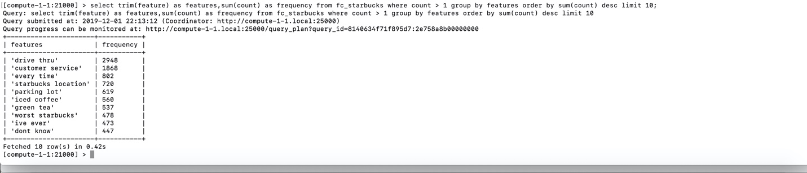

McDonalds:

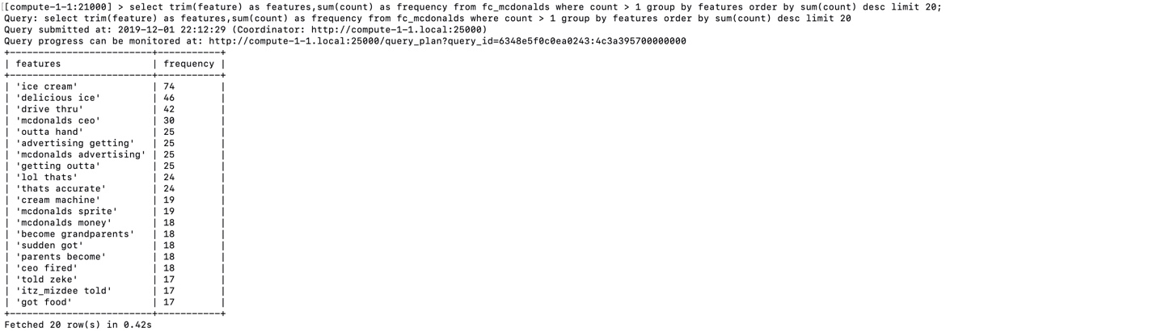

***PROBLEM -4:*** 1.Starbucks:

Reddit:

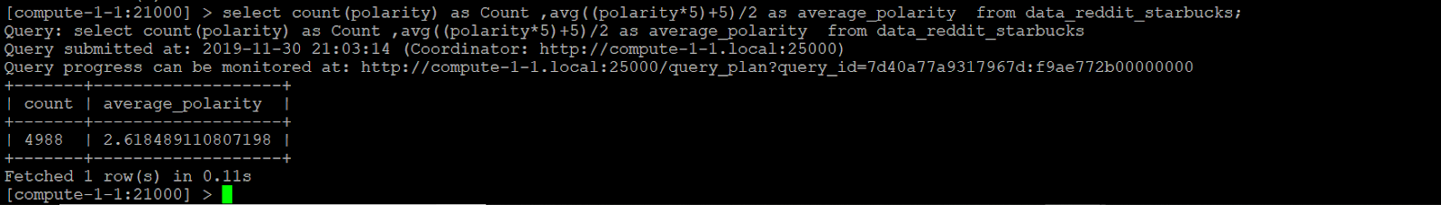

Twitter:

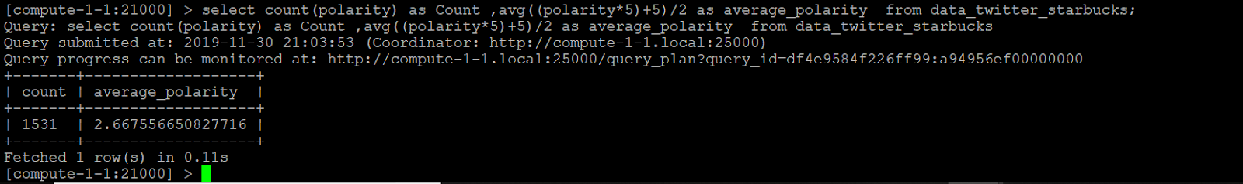

Yelp:

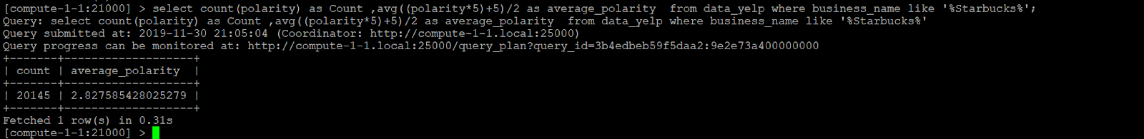

**2.** McDonalds:

Reddit:

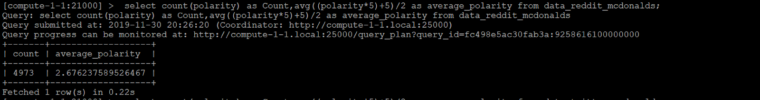

Twitter:

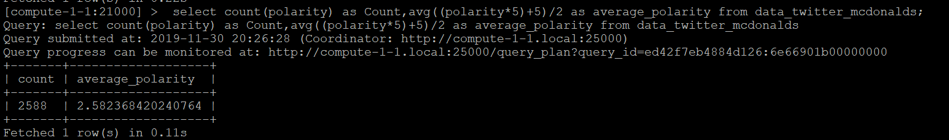

Yelp:

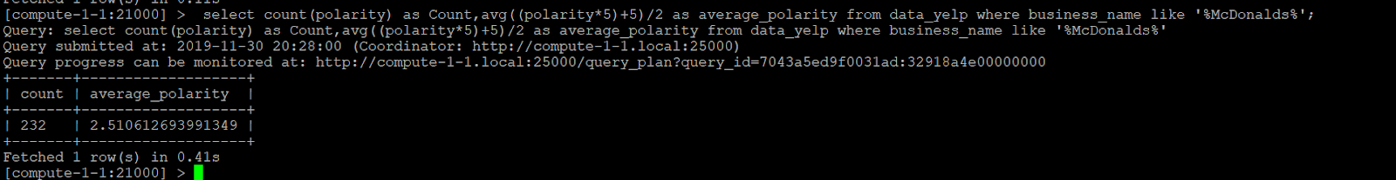

***PROBLEM-5*** :

1. **STARBUCKS**

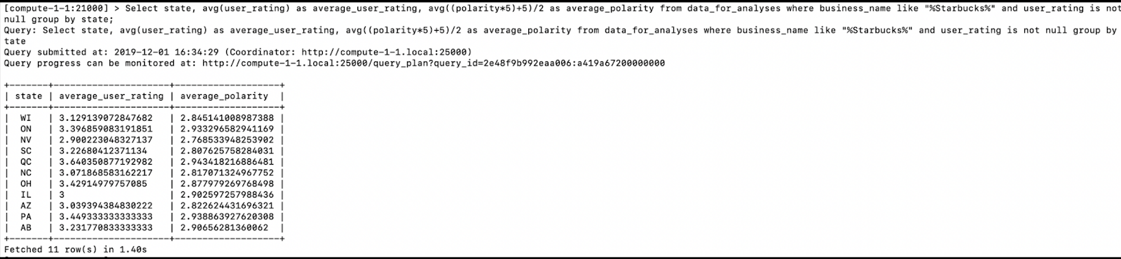

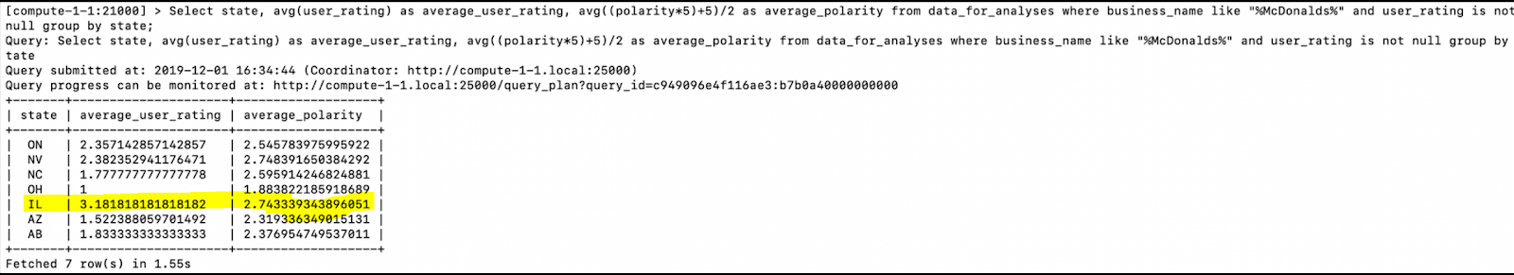

***PROBLEM -6:***

**STARBUCKS :**

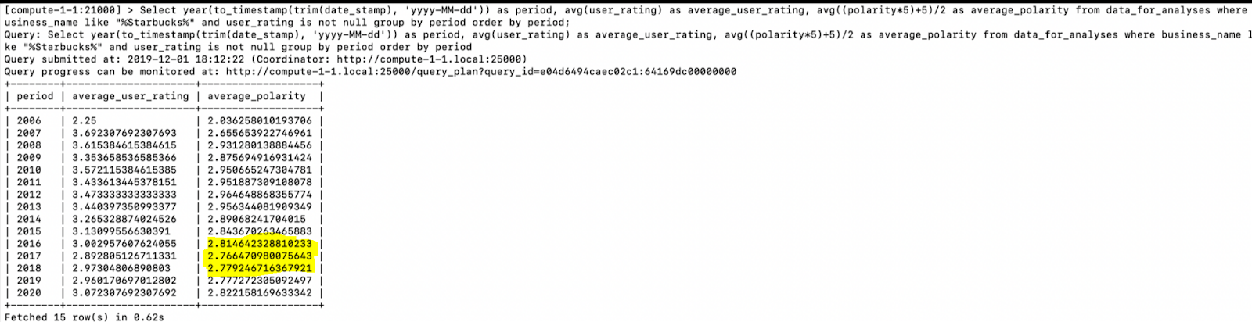

**McDONALDS** :

